Edify – website design document

**Table of Content**

1. Introduction
2. Requirements
   1. Software Requirement

## Prerequisite

1. Sitemap
   1. Services
2. Wireframes
3. Project Structure
   1. Front-end
   2. Host-end
4. System Modules
5. ER Diagram
6. Schema

**Introduction**

* Edify is an integrated application meant to provide training courses to its subscribers.
* The homepage welcomes the audience to our site. It tells the viewers what the website is all about. It allows them for a deeper exploration of the Edify website.
* An About-us page tells the viewer about what the organisation is all about, its purpose, its mission, its milestones or achievements. It also introduces the organisation’s who’s who.
* The Contact-us page is about establishing a direct contact with the viewer. This page provides a form, which a user could fill. This form contains viewer’s information and his question.
* The Login page provides an avenue for already registered users to login to the website so that they could explore the website, avail other benefits or join any courses.
* The pages have been kept simple to improve readability. Decorations and designs have been implemented as per need, but due care has been taken to avoid cluttering.

**Requirements**

* **Software Requirements**

|  |  |
| --- | --- |
| Operating System | Windows, macOS, Linux |
| Front-End | HTML, CSS, JavaScript, ReactJS, Bootstrap |
| Host-End | NodeJs, MongoDB |

## **Prerequisite**

In order to achieve this object, a basic knowledge of the following things is necessary:

**HTML** - HTML is the standard markup language for Web page. This provides the basic structure and text for any webpage. Various effects are applied on the HTML element to achieve the desired feel and look of a page.

CSS - CSS is the language we use to style an HTML document. It describes how HTML elements should be displayed, where it should be displayed. Basically, it controls the display properties of HTML elements.

JavaScript: It is used to add dynamic features to a page by manipulating the HTML and CSS elements by the help of programming. This helps in increasing interaction with the user by presenting and capturing responsive elements to the user.

Bootstrap: Bootstrap is a free and open-source CSS framework directed at responsive, mobile-first front-end web development. It contains CSS and JavaScript-based design templates for typography, forms, buttons, navigation, and other interface components.

ReactJS: React is a free and open-source front-end JavaScript library for building user interfaces based on UI components.

NodeJS: Node.js is an open-source, cross-platform, back-end JavaScript runtime environment that runs on the V8 engine and executes JavaScript code outside a web browser. It is used to write host-end for any web based application.

MongoDB: MongoDB is a source-available cross-platform document-oriented database program. Classified as a NoSQL database program, MongoDB uses JSON-like documents with optional schemas.

**Sitemap:**

A sitemap provides information about the pages, videos, files and other pages on your site. It shows the relationship between them.

* **Service Sitemap**

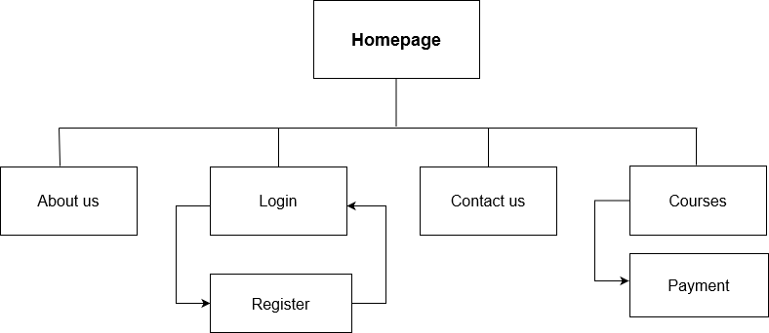

**Wireframes**

A website wireframe, also known as a page schematic or screen blueprint, is a visual guide that represents the skeletal framework of a website.

Wireframes are the foundation on which the commences the building a website. It usually comes after website architecture or sitemap or flowchart of the website’s pages and before the creative design phase.

In other words, Wireframes are simple black and white layouts that outline the specific size and placement of page elements, site features, conversion areas and navigation for a website.

Edify application has an extended functionality and screens. For the purpose of demonstration a few wireframes have been included in this document.

To view all the wireframes, visit the folder named as: **wireframes**

Login wireframe:

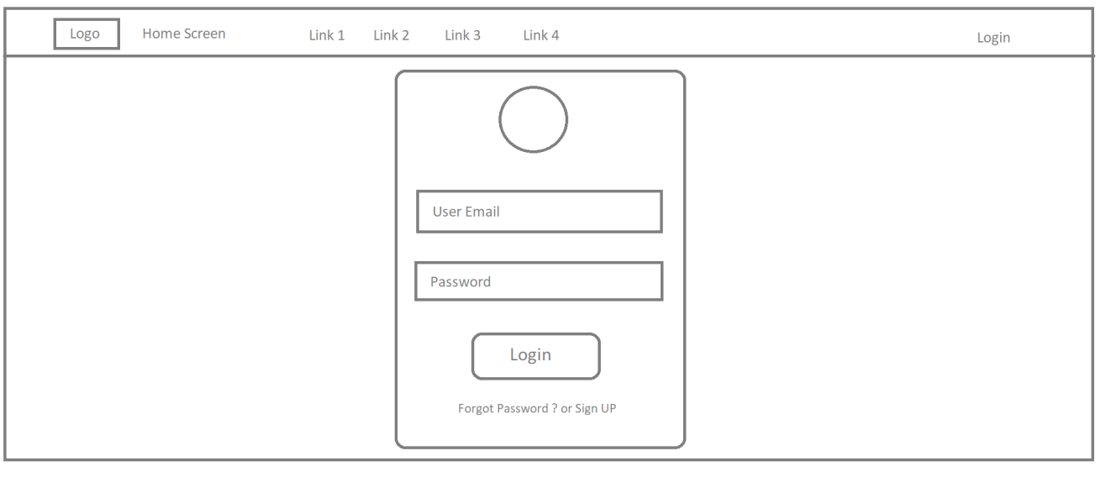

Register wireframe:

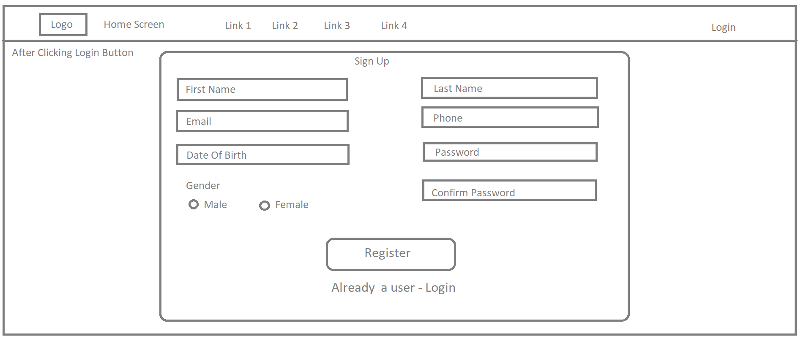

Footer:

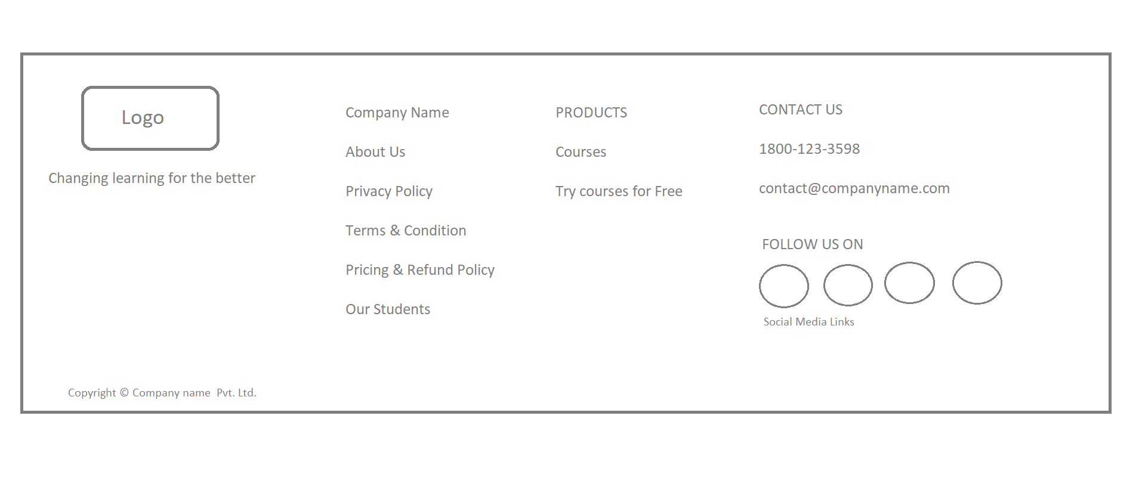

User Management: manage all users wireframe

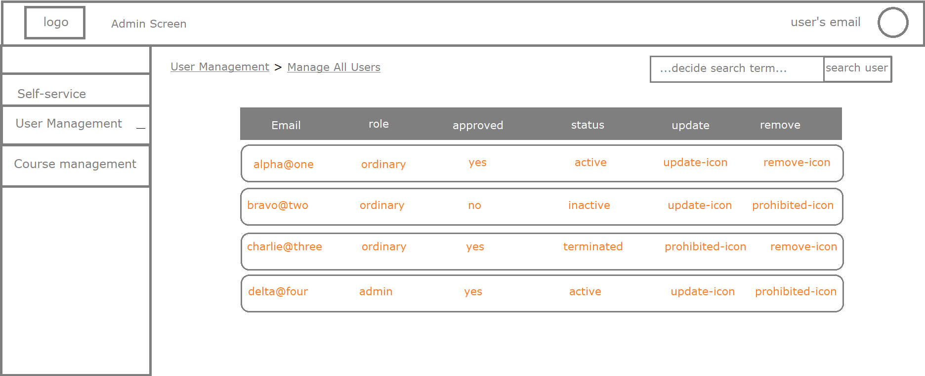

Course management: create new course wireframe

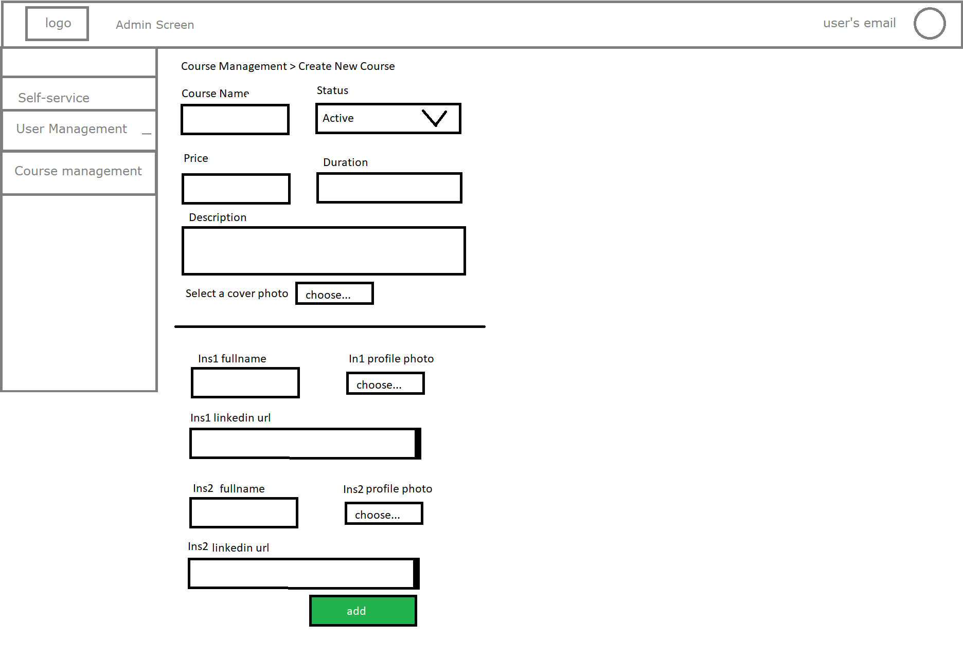

**System Module**

**Homepage**

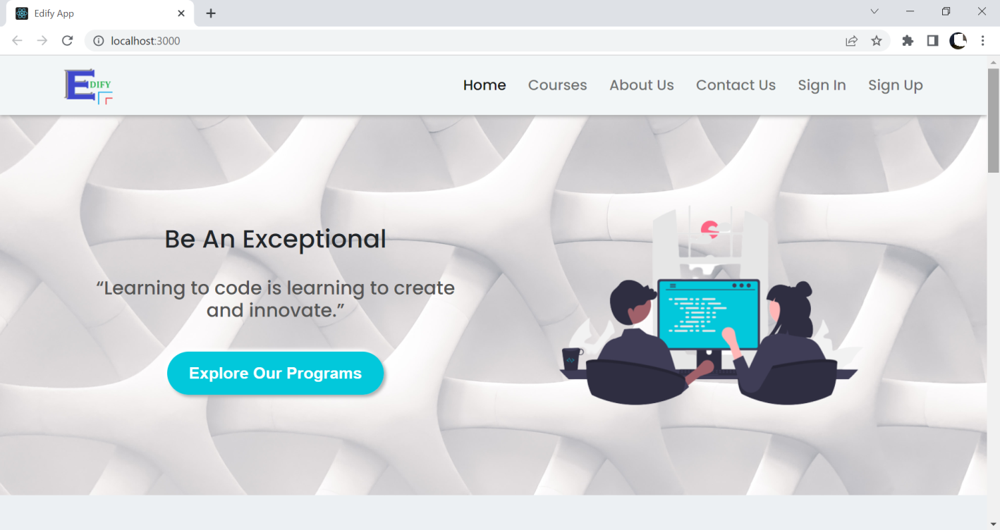

**Sign-in page**

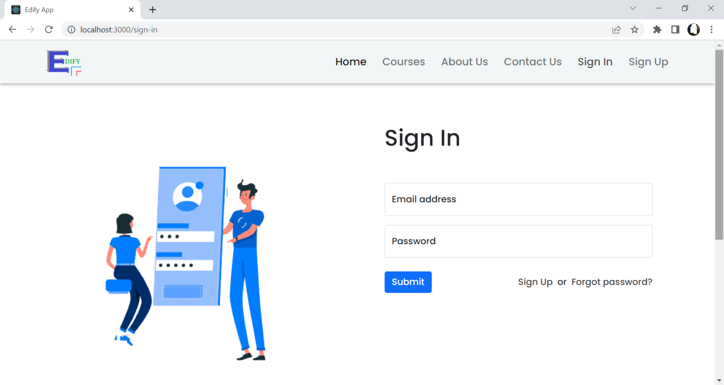

**Sign-up page**

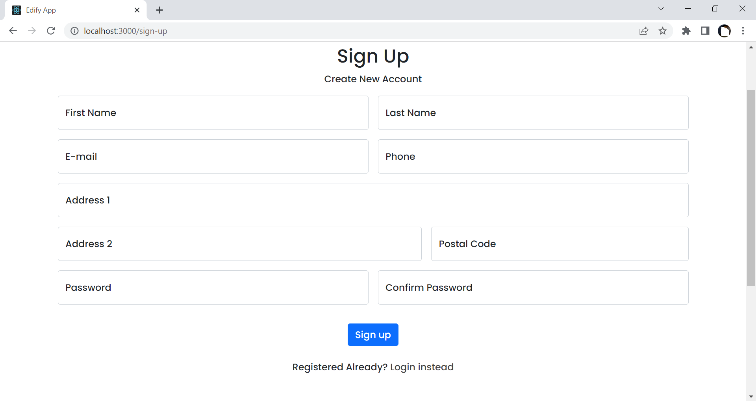

**Admin user- user management options**

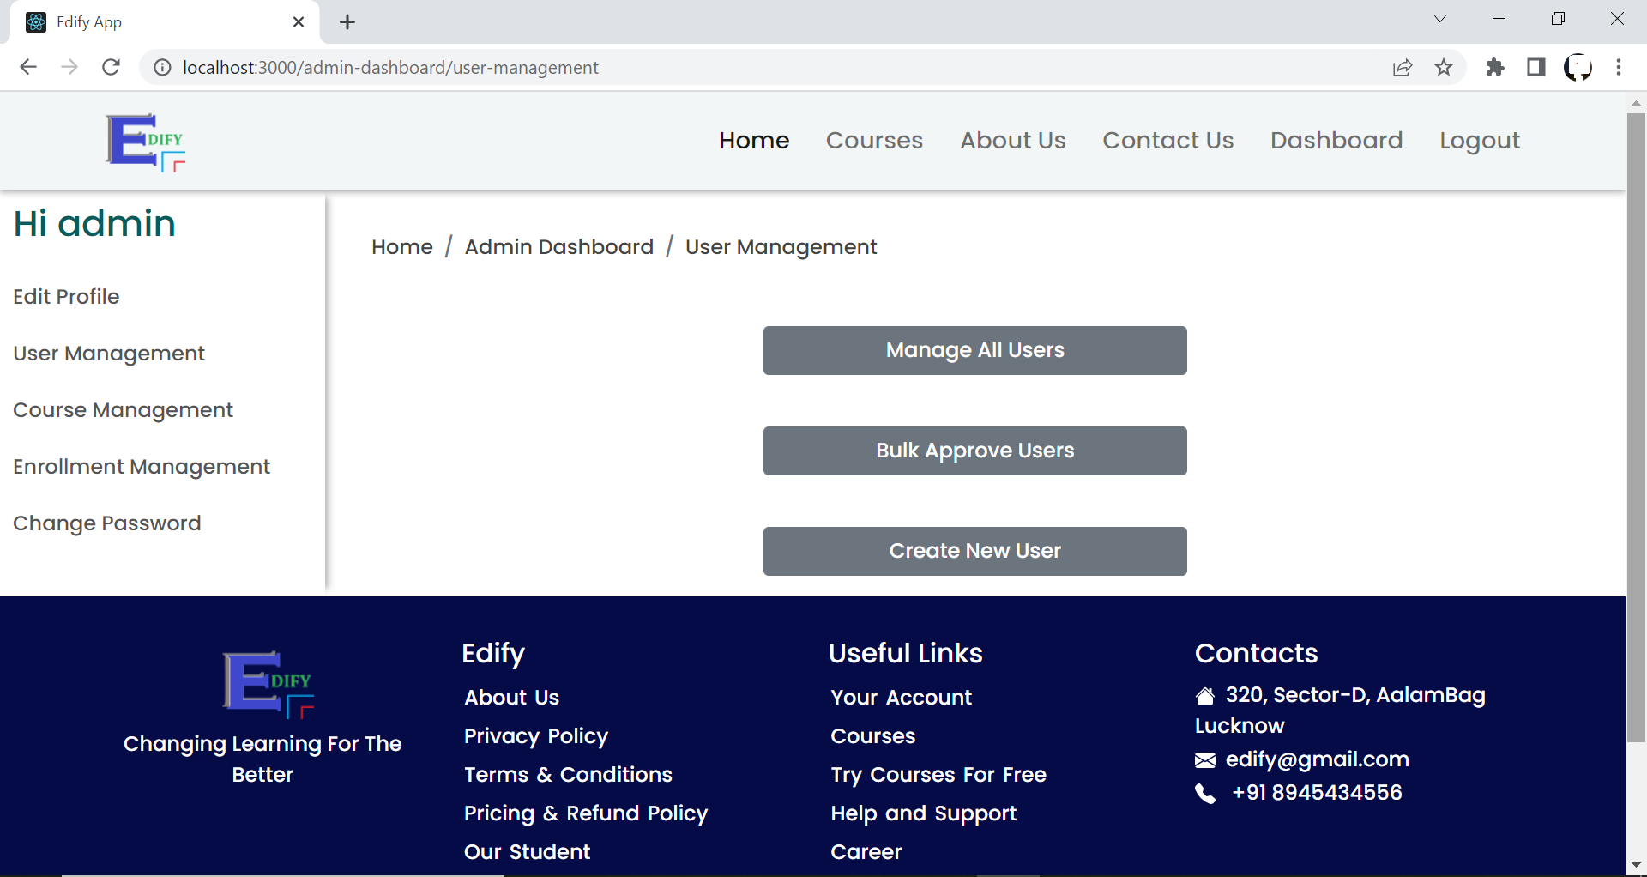

**Edit user**

**Edit profile**

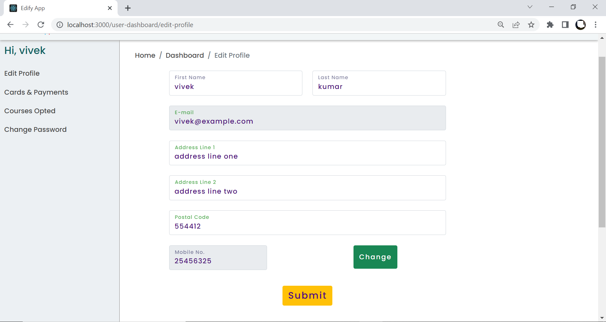

**Manage all users:**

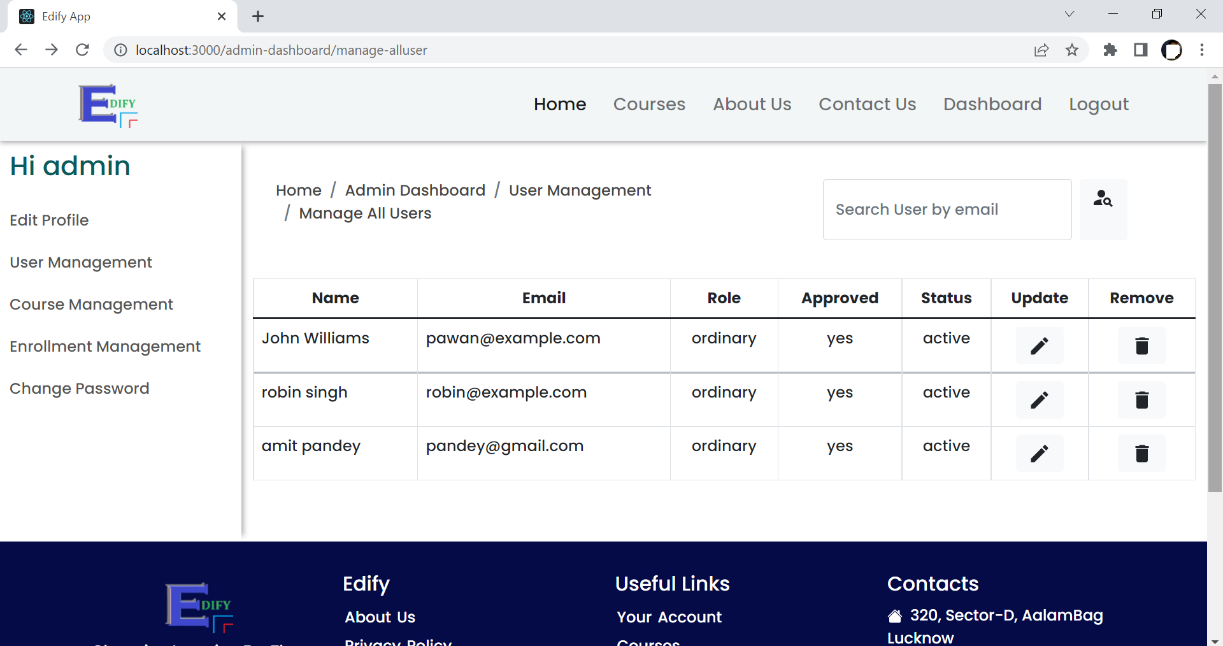

**Card management**

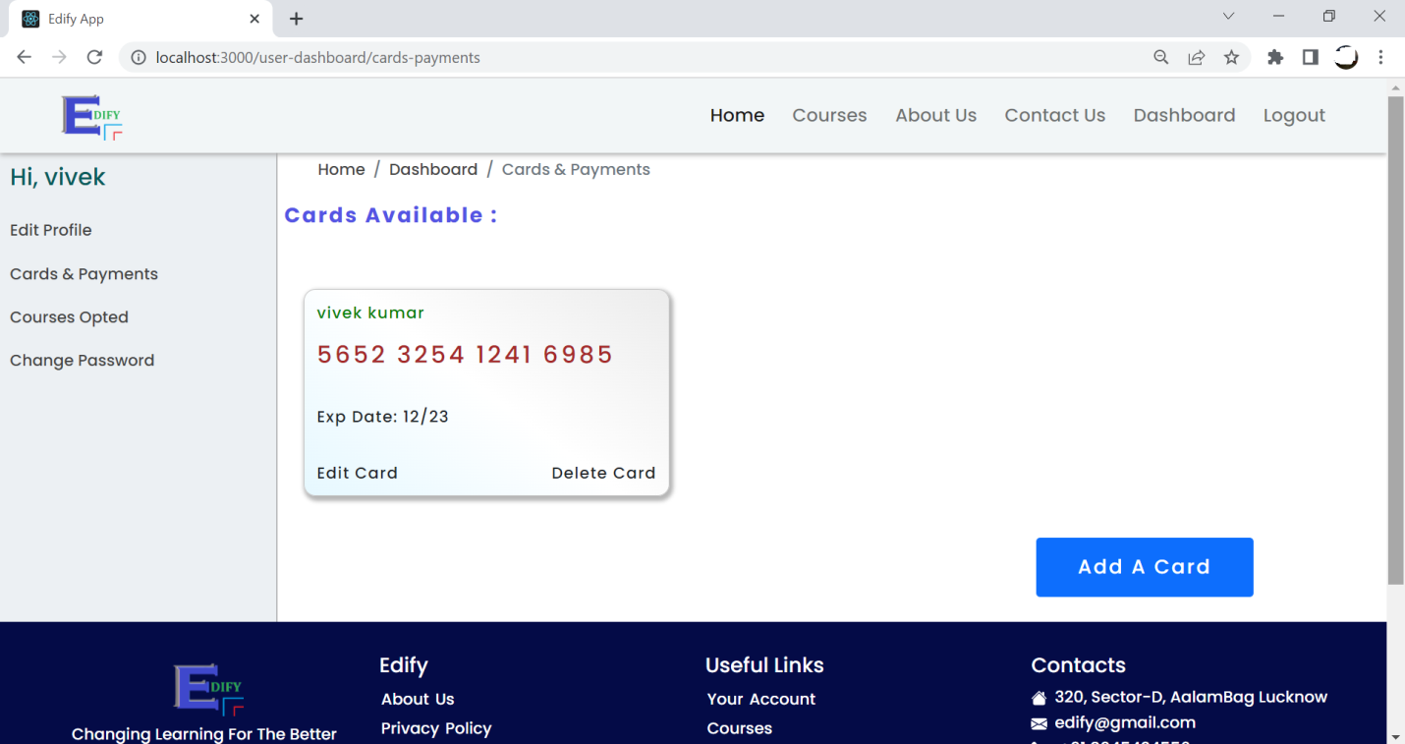

**Project Structure:**

**A) Front-end**

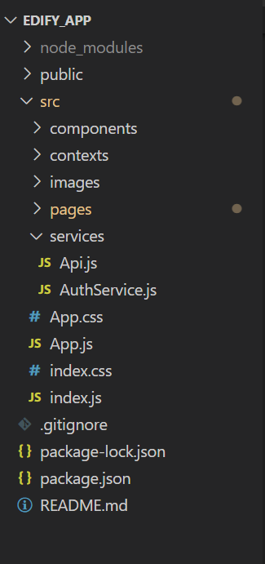

**B) Host-end**

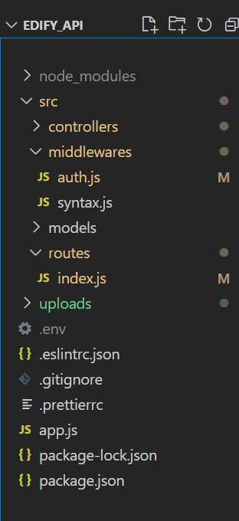

**ER Diagram:**

**A) For Edify application**

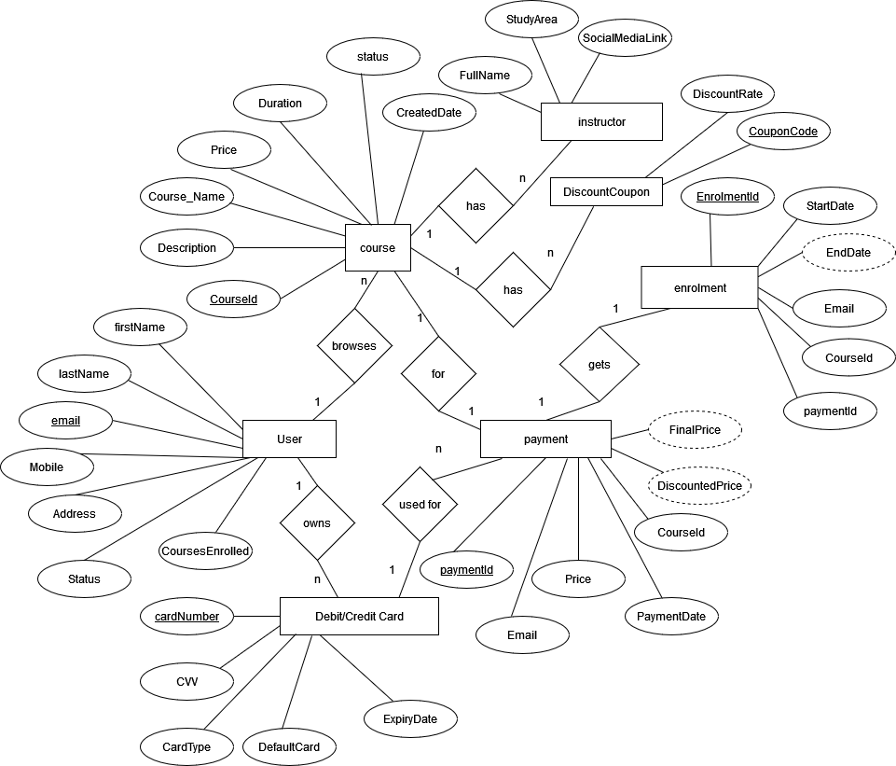

**B) For Edify application’s Administrator user**

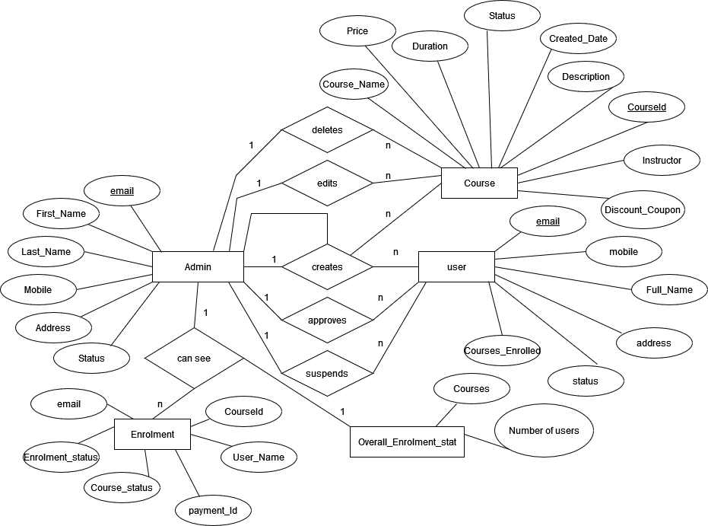

**SCHEMA**

